1. | Use the graph (right) to solve the following inequalities  a. $f\left(x\right)>0$b. $f(x)≤0$ | 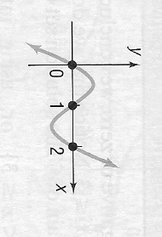

2. | Use the graph (right) to solve the following inequalities  a. $f\left(x\right)>0$b. $f\left(x\right)≤0$ | 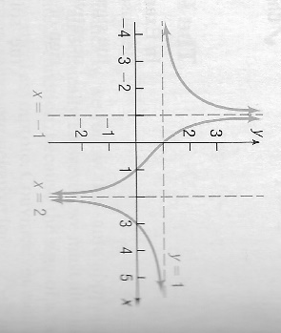

      - Solve the following inequalities algebraically. Be sure that you can both graph your solutions on a number line and state them in interval notation.
        - ${\left(x-5\right)}^{2}(x+2)<0$
        - $x^{3}-4x^{2}>0$
        - $2x^{3}>-8x^{2}$
        - $(x-1)(x-2)(x-3)≤0$
        - $x^{3}-2x^{2}-3x>0$
        - ${x^{4}>x}^{2}$
        - ${x^{4}>1}^{4}$
        - $\frac{x+1}{x-1}>0$
        - $\frac{(x-1)(x+1)}{x}≤0$
        - $\frac{{(x-2)}^{2}}{x^{2}-1}≥0$
        - $\frac{x+4}{x-2}≤1$
        - $\frac{3x-5}{x+2}≤2$
        - $\frac{1}{x-2}<\frac{2}{3x-9}$
        - $\frac{x^{2}(3+x)(x+4)}{(x+5)(x-1)}≥0$
        - $\frac{{\left(3-x\right)}^{3} (2x+1)}{x^{3}-1}<0$

      - Suppose $f\left(x\right)=x^{4}-1, g\left(x\right)=-2x^{2}+2$. Solve the inequality $f(x)≤g(x)$. Sketch the graphs of $f$ and $g$ together to check that$f$ actually lies below $g$ where your solution set says it should.

      - Suppose $f\left(x\right)=x^{4}-4, g\left(x\right)=3x^{2}$. Solve the inequality $f(x)≤g(x)$. Sketch the graphs of $f$ and $g$ together to check that$f$ actually lies below $g$ where your solution set says it should.

- Suppose that the daily cost $C$ of manufacturing $x$ bicycles is given by$C\left(x\right)=80x+5000.$Then the average daily cost $\overline{C}$ is given by$\overline{C}(x)=\frac{80x+5000}{x}$ . How many bicycles must be produced each day for the average cost to be no more than $100?

